Getting Started:
- Cut out the two game board pieces and tape together
- Cut along the border of the butterfly pieces then fold the paper so they will stand on their own.
- Cut out each of the numbered cards and the color cards.
How to play:
- Place the butterflies on “start”.
- Players take turns drawing cards and moving around the board.
- When they land encourage children to identify the color they have landed on. (A house rule could be that they must correctly identify the color or go back to the last square they were on.)
- If a player draws a color card they MUST move to the next square of that color. If there is no color in front of them they must move backwards to the nearest square of that color.
- The first player to reach the finish line wins!
Have fun!
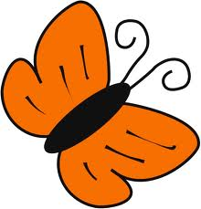

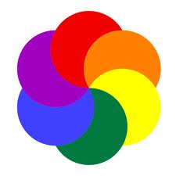
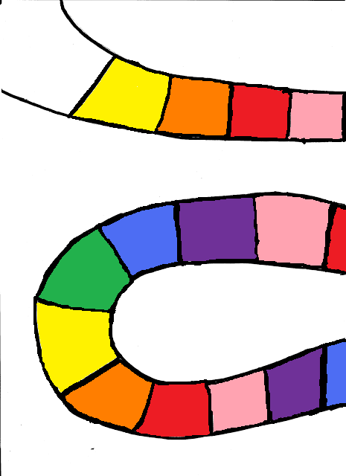
Start
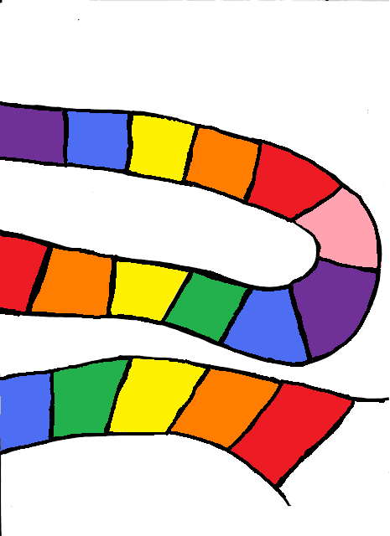
Rainbow Race

Finish

1 | 1 | 1 | 1
1 | 1 | 1 | 1
2 | 2 | 2 | 2
2 | 2 | 2 | 2
1 | 1 | 1 | 1
1 | 1 | 1 | 1
2 | 2 | 2 | 2
2 | 2 | 2 | 2
3 | 3 | 3 | 3
3 | 3 | 3 | 3
red | orange | yellow | green
blue | purple | pink

